Assignment No: 7

Data: { roll: 1, name: "Anu", age: 22, department: "IT", marks: 85 },
{ roll: 2, name: "Riya", age: 21, department: "CSE", marks: 78 },
{ roll: 3, name: "Aman", age: 23, department: "IT", marks: 92 },
{ roll: 4, name: "Neha", age: 20, department: "ECE", marks: 74 },
{ roll: 5, name: "Raj", age: 24, department: "CSE", marks: 88 },
{ roll: 6, name: "Simran", age: 22, department: "IT", marks: 81 },
{ roll: 7, name: "Karan", age: 21, department: "ECE", marks: 69 },
{ roll: 8, name: "Priya", age: 23, department: "CSE", marks: 95 }.
Q1. Display all documents
Query:db.studentCSE.find()
Output:
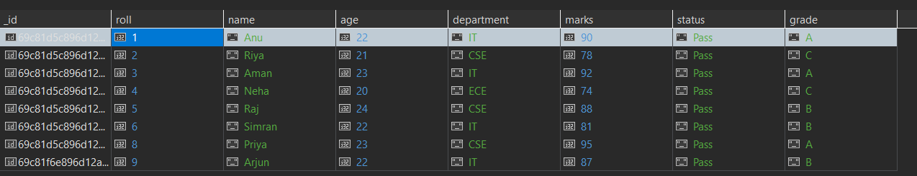
Q2. Find students from IT department
Query:db.studentCSE.find({ department: "IT" })
Output:
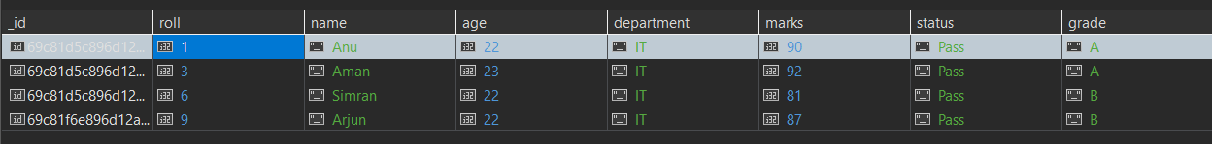
Q3. Find students with marks > 80
Query: db.studentCSE.find({ marks: { $gt: 80 }})
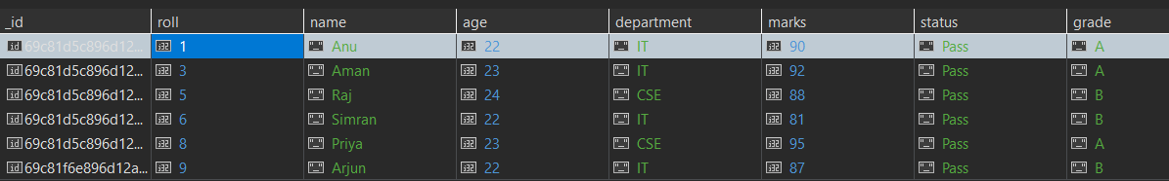
Q4. Insert one new student
Query:db.studentCSE.insertOne({ roll: 9, name: "Arjun", age: 22, department: "IT", marks: 87 })
Output:
Q5. Update marks of Anu to 90
Query:db.studentCSE.updateOne({ name: "Anu" },{ $set:{ marks:90 }})
Output:
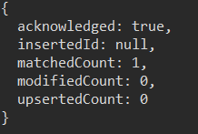
Q6. Add a new field "status: Pass" for all students
Query:db.studentCSE.updateMany({},{ $set: { status: "Pass" }})
Output:
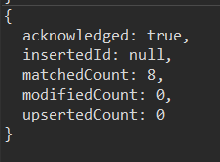
Q7. Delete all students with marks < 70
Query:db.studentCSE.deleteMany({ marks:{ $lt:70 }})
Output:{ acknowledged: true, deletedCount: 0 }
Q8. Count students in CSE department
Query:db.studentCSE.countDocuments({ department: "CSE" })
Output:3

Q9. Find total students in each department
Query:db.studentCSE.aggregate([{ $group: { _id: "$department", totalStudents: { $sum: 1 }}}])
Output:
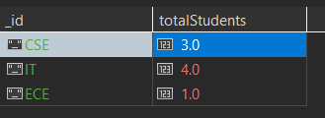
Q10. Find highest marks
Query:db.studentCSE.find().sort({ marks: -1 }).limit(1)
Output:
Q11. Find the second highest marks
Query:db.studentCSE.find().sort({ marks: -1 }).skip(1).limit(1)
Output:
Q12. Find students whose name starts with 'A' and marks > 80
Query:db.studentCSE.find({
name:{ $regex: "^A" },
marks:{ $gt:80 }})
Output:
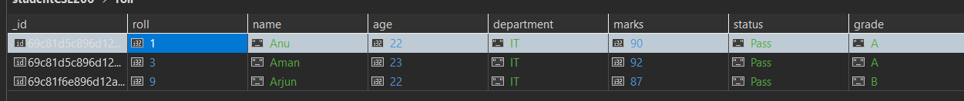
Q13. Display department-wise average marks, only for departments where avg> 80
Query:db.studentCSE.aggregate([{ $group:{ _id: "$department",avgMarks:{ $avg: "$marks" }}},{ $match:{avgMarks:{ $gt:80 }}}])
Output:
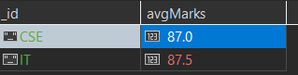
Q14. Find students with marks between 75 and 90, sorted by marks ascending
Query:db.studentCSE.find({ marks:{ $gte: 75, $lte:90 }}).sort({ marks:1 })
Output:
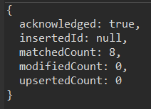
Q15. Add grade field based on marks
Query:db.studentCSE.updateMany({},[{ $set:{ grade:{ $switch:{ branches:[{ case:{ $gte:["$marks", 90]}, then: "A" },{ case:{ $gte:["$marks", 80]}, then: "B" },{ case:{ $gte:["$marks", 70]}, then: "C" }], default: "D" }}}}])
Output:
